# Macintosh HD:Users:z018620:Dev:Helps:Icons:RapiTag:RapiTagAppIcon-01.pngTagIt – User Guide

Version 1.2

12/16/2016

## Introduction

TagIt is an application for encoding RFID EPC test tags using the encodings used in Target’s concept store backroom. It works with proprietarily encoded EPC GIAIs that contain Target’s TCIN number. The app scans the target RFID EPC tag, and can scan printed bar codes on both blank RFID tags or UPC product labels or accept direct user input. Once the UPC barcode has been scanned, the TCIN is looked up via a RESTful call and a unique Serial Number calculated and the encode button is enabled. You can then manually encode the tag. Upon success, a green check is displayed and a new serial number generated. If not, a red circle with a line through it is displayed. In Scan Scan Encode mode, you scan the UPC barcode, and the barcode on the RFID tag. Encoding happens automatically as soon as both are read. This is the default mode upon startup. See instructions below to disable this mode.

## Requirements

An iOS device (iPod, iPhone, iPad) running iOS 9.x or higher (for Data Matrix barcodes)

A Zebra RFD8500 RFID reader.

The TagIt application via HockeyApp or direct install

## Setup

Launch HockeyApp and download and install TagIt

Before launching TagIt, you must connect the Zebra reader. Use iOS Settings to connect via Bluetooth.

If you are using a Bluetooth reader, click on the settings button and configure Bluetooth as outlined in the next section.

## Bluetooth Setup

### On the RFID reader

Turn on the Bluetooth reader

Press and hold the Bluetooth pairing setup button until the blue light is flashing slowly (if you just turned it on, or installed a new battery, it may already be flashing)

### On the iOS device

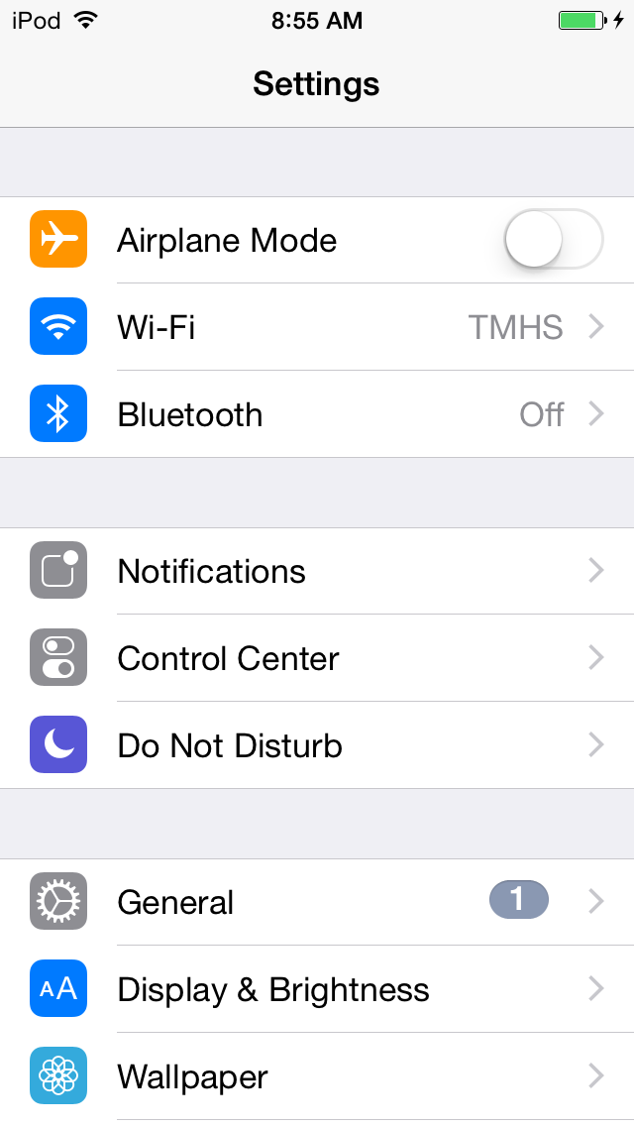

Open Settings and click on Bluetooth:

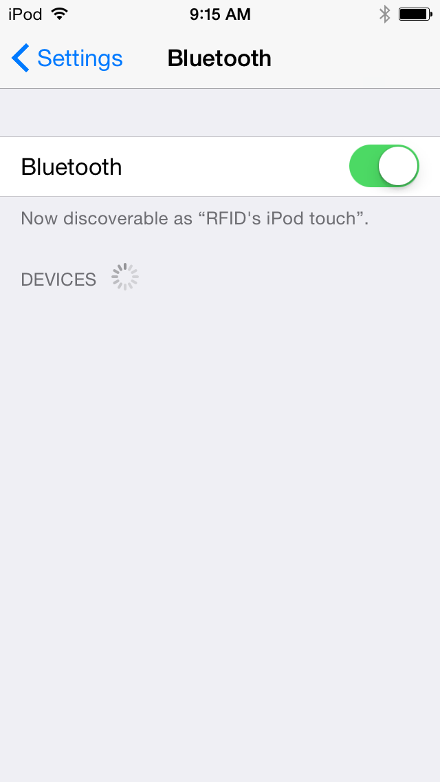Make sure Bluetooth is on:

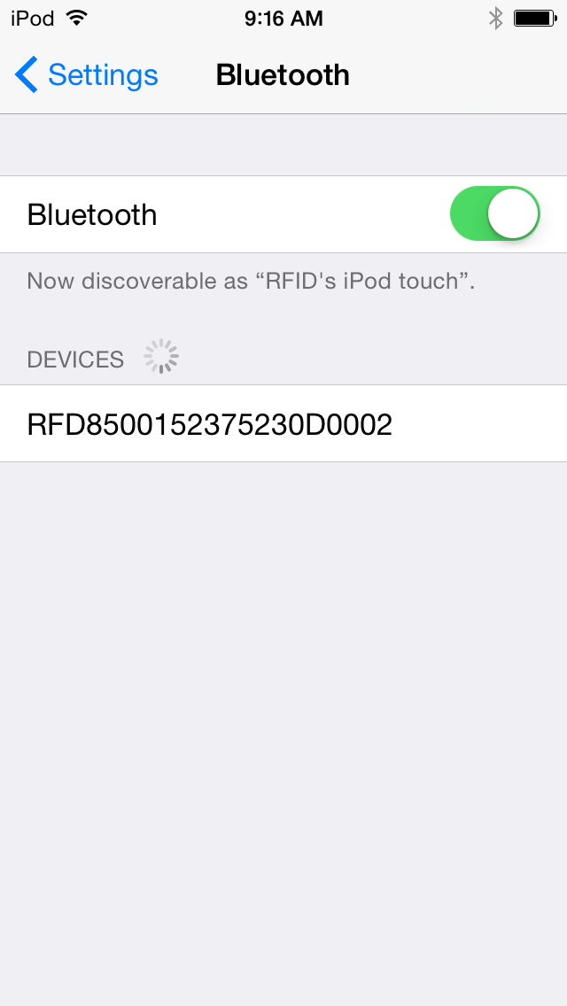

With the blue Bluetooth pairing light flashing on the RFID handheld, select the RFID device in the devices list:

### On the RFID reader

The Bluetooth pairing light will now begin flashing more quickly. Pull the trigger on the handheld to confirm pairing (this is a security feature – you must have physical possession of both devices to successfully pair them).

### Macintosh HD:Users:z018620:Pictures:iPhoto Library.photolibrary:Masters:2015:09:21:20150921-091654:IMG_0014.PNGOn the iOS device

The RFID device should now show as connected. If not, repeat the steps in this section until a successful connection is established:

You should now be paired, and can open the application.

## Launch TagIt



If the reader was connected, you should see the RFID Battery Life displayed (see troubleshooting if not), and the RFID label should say “Scanning for tags” (see troubleshooting if not):

Now, scan the UPC of a product to encode:

Once scanned the TCIN is looked up and automatically entered, but you can also enter a TCIN manually in the text field.



Note: you can also manually enter the UPC in the text field. You must hit return to accept any manual entries:

Second, scan the data matrix or barcode on the RFID tag to be endoded (Note, you can do this in either order):



After scanning the RFID tag’s barcode, make sure you hold the tag 2 to 5 inches away from the reader (set or hold it in front of the reader while reading the barcode for best results):

Note that the TCIN is autopopulated, and a unique serial number generated, and the tag is automatically encoded. If successful, all fields are cleared and you see a green check:

If it failed, the fields are not cleared, and you see a red circle with a slash:

Note: the serial number must be auto generated to make sure it is unique, so this field is not editable.

If you want to exit automatic Scan Scan Encode mode, turn the device sideways and disable the toggle button:





In this mode, the reader tries to read the actual RFID tag to be encoded, so make sure you are only holding one within range. (Note: If you can’t read the RFID tag, you can still scan the printed barcode on the RFID label as well, but if you can’t read the tag, you probably won’t be able to encode it either). Now scan the UPC barcode on the product to be tagged:

And you now see all the information is ready (UPC, TCIN, Serial Number), and the manual encode button is enabled in the upper right.

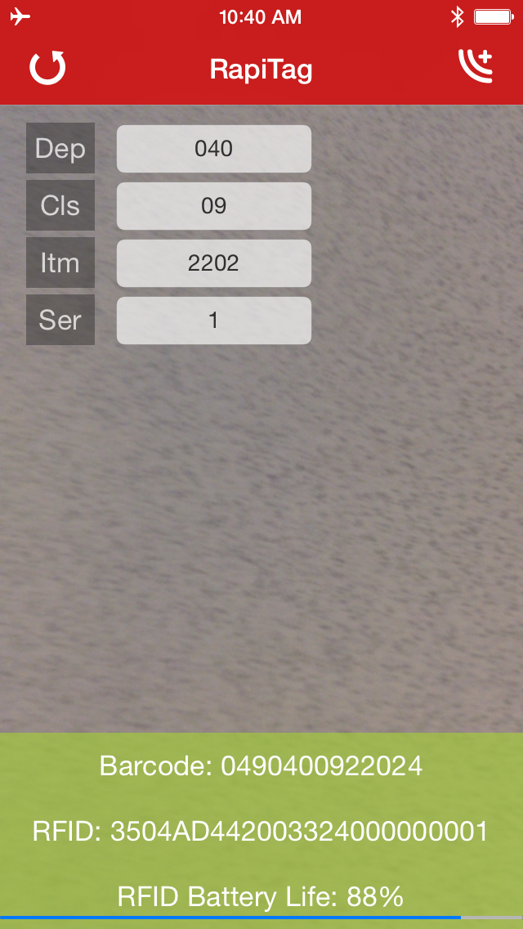

Once both the EPC tag is read, and the proper input collected, the Encode button in the upper right is enabled:

Keeping the EPC tag in range, if you press the encode button, TagIt will attempt to encode the tag. If successful, a green check mark is displayed and the Barcode and RFID fields will be green:

If it fails, then a red circle with a line through it will be displayed, and the Barcode and RFID fields will be red.

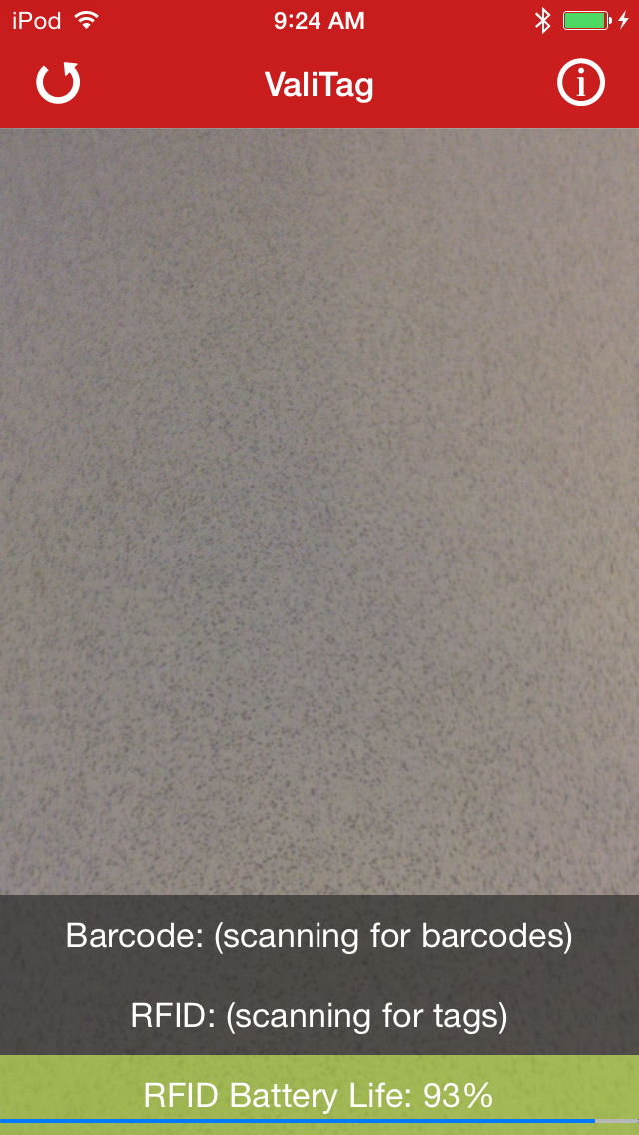To read another tag, or start over in manual encode mode, press the reset button on the upper left:

Important note: the power settings on the RFID reader have been turned down enough so that only tags within the immediate range of the reader will be read and encoded. You should be able to keep tags at arm’s reach away on either side and they won’t be affected, but occasionally they are. You may need to test this in your environment until you are sure you are reading and encoding only the RFID tag that is in range. To keep the application simple, these settings are not configurable.

When the battery of the reader gets too low, charge it or replace the battery.

## Basic Troubleshooting

* **No Battery life displayed**
  + This can be an indication that the reader is not properly connected, but not all readers report their battery life in the same manner, so it is not a guarantee.
  + Check the reader connections (iOS Bluetooth settings)
* **Connecting to reader message**
  + If this message is displayed, press the reset button in the upper left and try again.
  + If after a couple of resets it still won’t connect
    - If you are using a Bluetooth reader, proceed to the next step
* **Bluetooth connection fails**
  + Exit RapiTag
  + Go into iOS Settings, Bluetooth and click on the ‘i’ button to the right of the RFID reader
  + Select “Forget this Device” and accept

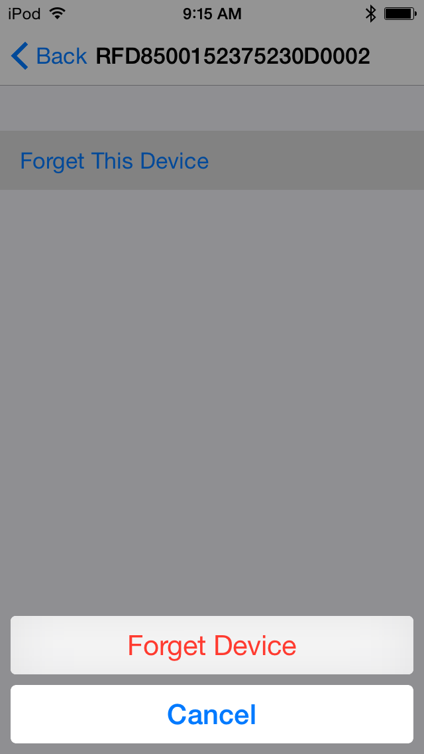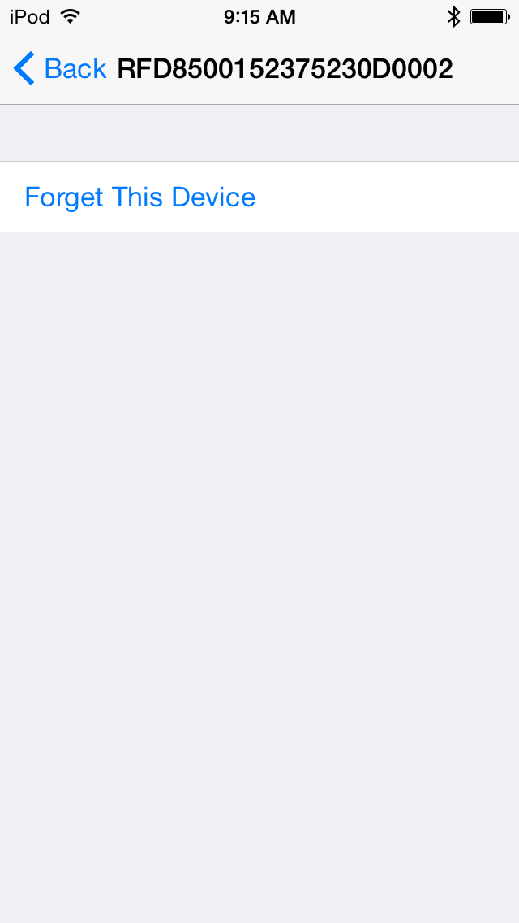

* + Once forgotten, go through the setup steps outlined in “Bluetooth Setup” to reconnect the reader.
  + Wait until it is connected and then relaunch RapiTag.
  + The reader should connect automatically.